Verifying Drives&Images

FTK Imager allows us to calculate MD5 and SHA1 hash values for entire drives and images to verify that copies of evidence items have not been altered in any way from the originals.

To verify a drive or image

1. In the Evidence Tree, select the drive or image we want to verify.
2. Do one of the following:
   * Click **File > Verify Drive/Image**.
   * Click the **Verify Drive/Image** button  on the *Toolbar*. 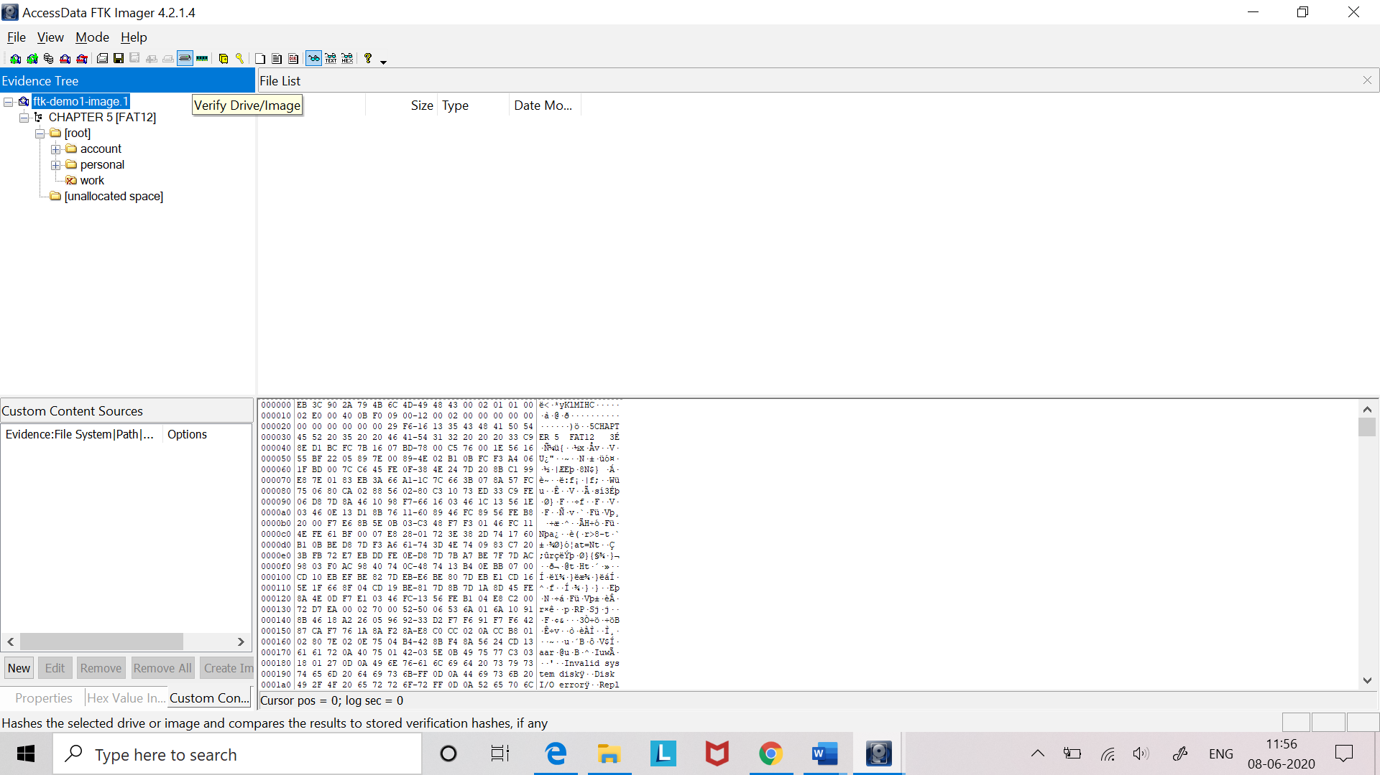
3. A progress dialog appears, showing:
   1. The name of the drive or image we are verifying.
   2. A graphical progress bar.
   3. The amount of data (in MB) that has been verified and the total amount to be verified.
   4. Elapsed time since the verification process began
   5. Estimated time remaining until the process is complete
4. Once the verification process has successfully completed, the Drive or Image. Verify Results summary screen appears, showing the following:

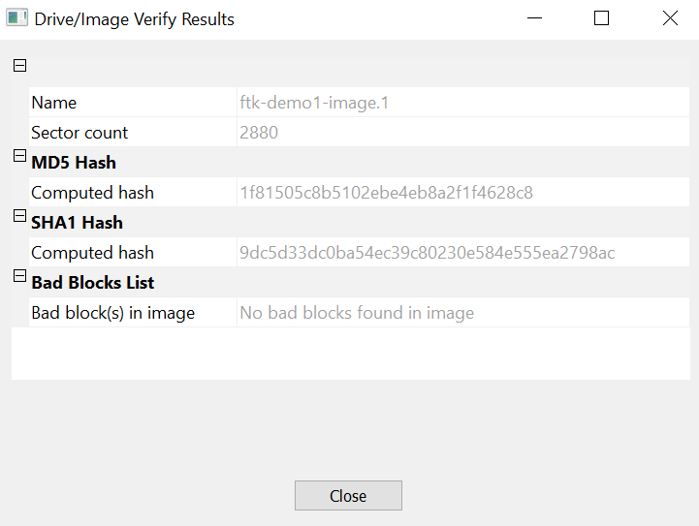

* 1. Name of the drive or image that was verified.
  2. Number of sectors in the drive or image.
  3. MD5 hash computed for the drive or image.
  4. If you verified an image that contains its own hash value, such as a .S01 (SMART) or .E01 (EnCase) image, the hash value stored inside the image is also displayed.
  5. Whether the hash value stored in the image matches the hash value computed by FTK Imager.
  6. SHA1 hash computed for the drive or image.
  7. Number of bad sectors(blocks) found.